/boot partition is completely wiped out or corrupted in RHEL 7

Create an issue
Become root
cd /boot
ll
rm -rf *
ll
init 6

/boot partition is completely wiped out or corrupted then getting an error as shown in the image below

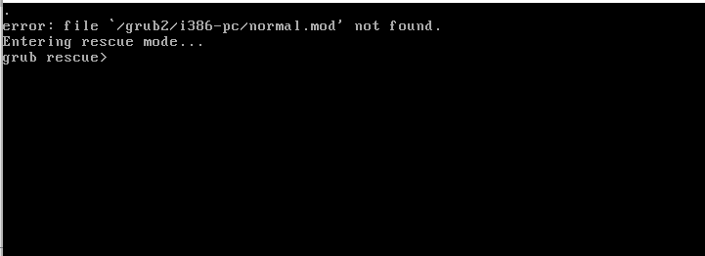

Attach dvd.iso as shown in the image below

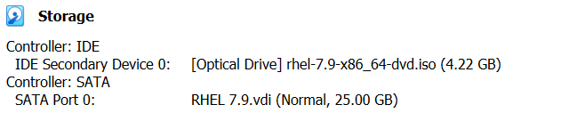

Reset OS through VM
Press Enter on Troubleshooting mode

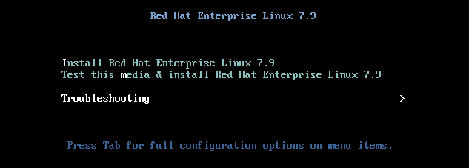

Press Enter on Rescue a Red Hat Enterprise Linux system (Rescue mode)

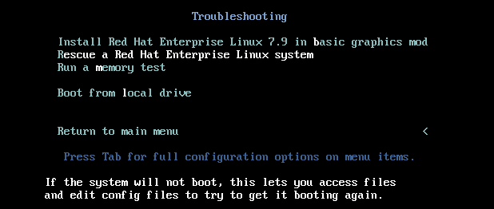

1) Continue 1 Enter

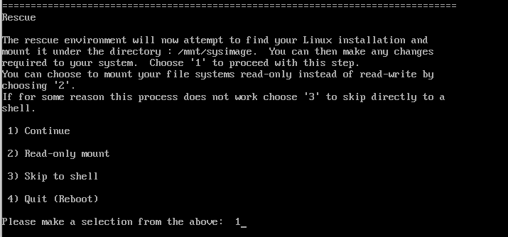

Enter

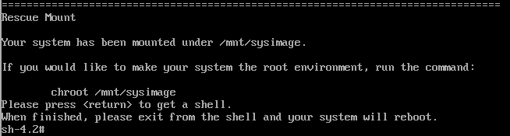

df -h
chroot /mnt/sysimage
df -h
cd /boot
ls
cd /
mount /dev/sr0 /mnt
cd /mnt
ls
cd Packages/
ls
pwd
uname -r
ls -ltr | grep -i kernel
rpm -ivh kernel-3.10.0-1160.e17.x86_64.rpm –force
cd /boot
ls
cd /mnt/Packages/
ls
ls -ltr | grep -i grub
rpm -ivh grub2-2.02-0.87.e17.x84_64.rpm --force
cfdisk /dev/sda (To find the boot partition)
grub2-install /dev/sda1
cd /boot
ls
cd /mnt/Packages/
rpm -ivh redhat-logos-70.7.0-1.e17.noarch.rpm –force
(Press Tab key after rpm -ivh redhat-logos)
cd /boot
ls -ltr
cd grub2
ls -ltr
grub2-mkconfig -o /boot/grub2/grub.cfg
ls -ltr
exit

Remove dvd.iso as shown in the image below

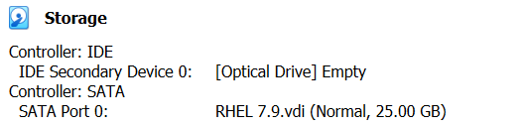

Reset OS through VM
The system is started booting up without any issue

